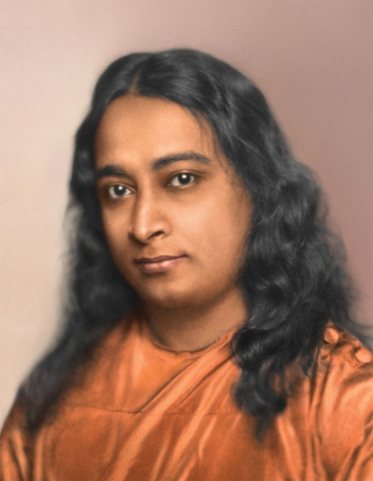

Kriya Tour Weekend Events Schedule

Friday, March 20 – Kriya Tour Weekend Begins
Registration and Specialty Rooms Open
3:00 PM – See reverse side for rooms and times

Marriott Ballroom
7:00-9:00 PM - Public Lecture and Informal Gathering - Marriott Ballroom

Saturday, March 21
Marriott Ballroom
10:00 AM-12:00 PM - Techniques Review Class and Guided Meditation *
6:00-9:00 PM - Kriya Yoga Initiation **

Registration and Specialty Rooms – See reverse for rooms and times

Sunday, March 22
Marriott Ballroom
8:30-10:00 AM- Kriya Technique Review **
10:30-11:15 AM - Meditation
11:30 AM-12:30 PM - Inspirational Service
12:45-2:00 PM - Reception and Fellowship

Registration and Specialty Rooms – See reverse for rooms and times

* Must be a SRF/YSS lessons student to attend
** Must be a SRF/YSS Kriyaban or new initiate to attend

Room Schedule ***
Friday
Information desk - 3:00-10:00 PM
Meditation room (Santa Fe) - 3:00-6:45 PM and 8:00-10:00 PM
Video room (Carlsbad) - 3:00-6:30 PM
Parent-Child (Carlsbad) - 6:30-8:00 PM
Lessons & Kriya Registration/Counseling (Cimarron/Las Cruces) - 3:00-6:45 PM & 8:00-10:00 PM
Bookroom & Reading Room (Salons G&H) - 3:00-6:30 PM and 8:00-9:30 PM

Saturday
Information desk - 8:00 AM-9:00 PM
Meditation room - 8:00-9:45 AM, 12:00-4:30 PM, and 6:00-10:00 PM
Video room - 12:30-6:00 PM and 6:30-8:00 PM
Parent-Child - 9:45 AM-12:00 PM
Bookroom and Reading Room - 12:30-4:30 PM
Lessons & Kriya Registration / Counseling - 8:00-9:45 AM and 12:00-4:30 PM
Fruit and Flowers (Salon A) - 1:00-5:00 PM

Sunday
Information desk – 8:00 AM-3:00 PM
Meditation room - 8:00-10:15 AM
Video room - 8:30-10:00 AM
Parent-Child room - 10:30 AM-12:30 PM
Bookroom and Reading Room - Closed
Registration and Counseling - Closed

Video Room Schedule (Carlsbad)
Friday - 3-8 PM
3:00-4:30 PM - Glimpses of a Life Divine
4:45-6:00 PM – Paramahansa Yogananda - Return to India
6:45-6:55 PM - The Lion Who Became a Sheep
7:00-8:00 PM - Public Lecture / Parent Child (Audio from Public Lecture)

Saturday - 9:45 AM-8:00 PM
10:00 AM-12:00 PM - Meditation Techniques Class *
12:30-1:45 PM - Paramahansa Yogananda - Return to India
2:00-3:30 PM - Glimpses of a Life Divine
3:45-4:45 PM - Paramahansa Yogananda - Return to India
6:30-8:00 PM - AWAKE: The Life of Yogananda

Sunday – 8:30 AM-12:30 PM
8:30-10:00 AM - AWAKE: The Life of Yogananda
11:30 AM-12:30 PM - Inspirational Service (Audio from service)

*** Rooms are closed during classes with the exception of the Parent-Child Room

